Name: _____________________ Date: _______

POLYMERIZATION-SLIME LAB

I. Pre-Lab Discussion:
Polymerization is a very important chemical process which produces many products
found in our daily living. Artificial fibers (nylon, dacron), synthetic rubber, plastics
(vinyl, polyethylene, PVC pipes), chewing gum, starch, wool and paint are just a few
polymer products. Polymerization is brought about by the joining of small molecules
to form long chains containing a repeating group. These small molecules are referred
to as monomers. The joining of monomers can be achieved by the processes of
addition polymerization or condensation polymerization. Chemists vary the use of
catalysts, the choice of monomers and the selection of other conditions to control the
reaction.
The chemistry by which slime is produced involves the borate ion crosslinking with
the PVA. PVA is used as a thickener, stabilizer, and binder in cosmetics, paper cloth,
films, cement and mortars. The structure of poly(vinyl alcohol) is:
Borax hydrolyzes in water to produce boric acid and the OH- ion

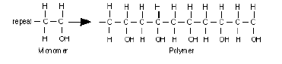
B4O7-2(aq) + 7 H2O → 4 H3BO3(aq) + 2 OH-(aq)

The boric acid further reacts with water to form a borate anion.

H3BO3(aq) + 2 H2O → B(OH)4-(aq) + H3O+(aq)

The tetrahedral borate ion “crosslinks” with the poly(vinyl alcohol) to yield slime and
water.

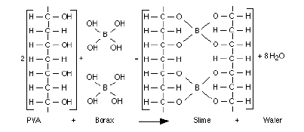

Slime is a non-Newtonian fluid that is dilatant. That is, under stress, the material
dilates or swells. Other stress-thickening materials are quicksand, wet beach sand,
starch solution, some printer’s inks and Silly Putty®.
Under low stress, such as slowly pulling on the material, it will flow and stretch. If
you are careful you can form a thin film. Pull sharply (high stress) and the material
breaks. Pour the material from its container then tip the container upward slightly,
the gel will self siphon. Put a small amount of the material on the table top and hit it
with the palm of your hand, there is no splashing or splattering. Throw a small piece
on a hard surface, it will bounce slightly. Stuff the material through a small hole in
your hand and “die swell” occurs as it emerges.
See how many characteristics and observations your students can come up with.
Most of all have fun!
II. Materials & Equipment:

250 mL beaker popsicle stick
0.5g guar gum Distilled water
saturated borax solution 100 mL graduated cylinder
Food coloring 10 mL graduated cylinder

III. Procedure:
1. Using the 100 mL graduated cylinder, measure out 70 mL of room temperature distilled
water.
2. Add food coloring.
3. Gently add the guar gum to the water stirring continually. Do not dump all the guar gum in
at one time. IMPORTANT: Stir the guar gum and water for at least two minutes
continually.
4. Using the 10 mL graduated cylinder add 6-10 mL of saturated Borax solution. The exact
amount you will need changes from day to day, you will have to experiment to get the
perfect mix.
5. Store slime in a plastic zip-lock bag.

IV. Data:

V. Conclusion:

